2017 BICYCLE & SCOOTER SAFETY RODEO
ROCKPORT ELEMENTARY SCHOOL K – 4TH GRADE
Attend a FREE FUN Event with a focus on SAFETY!

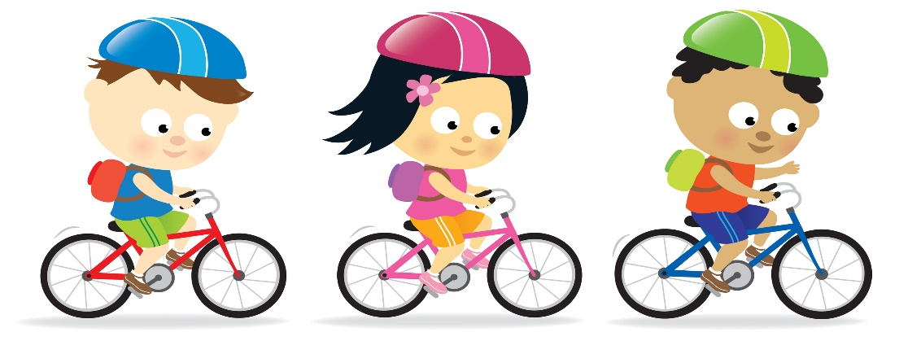
Bike Registration with RPD ● Helmet Fit Testing
Bike & Scooter Safety Inspections ● Bike Obstacle Course
Touch a Cruiser ● Hot Dogs and Refreshments

Date: SATURDAY, JUNE 3RD
(RAIN DATE: SUNDAY, JUNE 4TH)
Time: 2:00PM – 4:30 PM
Location: ROCKPORT HIGH SCHOOL TRACK
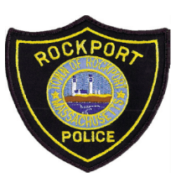
SPONSORED BY THE ROCKPORT POLICE DEPARTMENT
AND
THE ROTARY CLUB OF ROCKPORT

