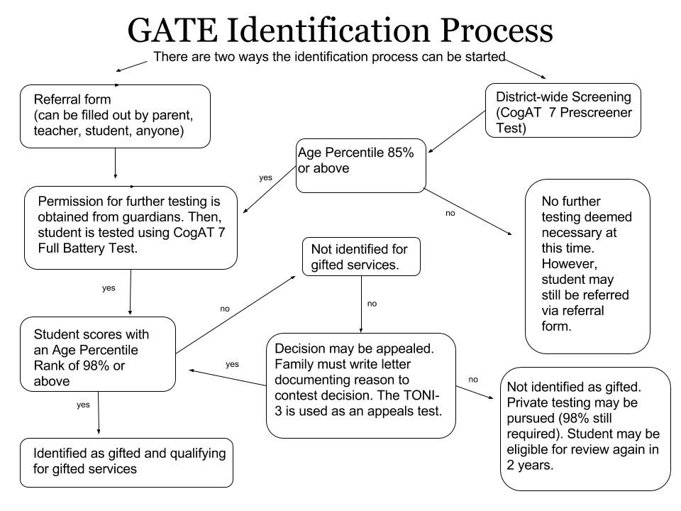

**Does a student have to attend the “send-out” program in the elementary grades or “gifted-studies” class at CMS?**

No. This a parent and student based-decision. We encourage students to participate with like-minded peers in this challenging, creative setting.

**Does a student ever become “exited” from the G.A.T.E. program?**

No. Once a student is identified as “gifted” they remain identified within the PCSD#6 program.

**Why should a gifted student be allowed to attend the send-out program if they misbehave or have difficulty-completing classwork?**

Gifted students benefit from interaction with like-minded peers. Poor work-habits or classroom behavior may have an underlying cause. We try to work closely with classroom teachers to problem solve strategies that may work with individual students.

## Common Questions

* Unusual or adult sense of humor
* Vivid imagination
* Creative
* Early and developed moral concern
* Keen sense of justice
* Often goal oriented
* Inquisitive nature
* Broad knowledge base
* Intense
* Independent
* Keen insight
* Able to synthesize and comprehend the “heart of the matter”
* Emotionally sensitive to others; may be labeled as “oversensitive”
* High energy levels. May not want sit still *ever*
* May be bossy, rebellious, or tactless
* Extensive, quick, and detailed memory
* Perfectionist tendencies
* Possibly has high test scores, but low rate of classwork completion
* Nonconformist
* May challenge authority
* May not work well in groups
* May not understand social niceties or feel they are facades
* Disruptive (AKA “class clown”)
* Needs novelty

# Gifted Student Common Traits

### Kristian Olson,

### Elementary Instructor

### Eastside ES—(307) 587-4275 Ext. 5541; kristanolson@park6.org

### Amy Fulton, Secondary Instructor

### CMS/CHS (307) 587-4273 Ext. 5264; amyfulton@park6.org

### Kelli Alexander,

### Para-Educator

### Eastside ES—(307) 587-4275 Ext. 5541; kellialexander@park6.org

PCSD#6

G.A.T.E.

Referral

Process

Students who are previously identified for gifted programs in other districts are not automatically qualified for the G.A.T.E. program in PCSD#6. Please provide documentation of any testing assessments that were used in previous identifications processes. The G.A.T.E. Department will review this information to determine if the student qualifies at the 98% or above. If no documentation can be provided, the student will need to be referred and assessed using the PCSD#6 referral process.

* Parents
* Teachers*
* Individual Students
* Other Interested Adults*

*\*As a courtesy, please notify parents/guardians if you are referring a student.*

Referring a student *does not guarantee* the student will be identified as qualifying for gifted services.

The “Referral for Gifted Services” form can be found in school offices or downloaded from the Gifted and Talented page on [www.park6.org](http://www.park6.org).

Completed forms can be dropped off at Eastside Elementary, Cody Middle School, or Cody High School. They can also be submitted via interschool mail or the U.S. post office.

## Transfer Students

***Parental or guardian permission to test students must be given prior to administering the CogAT full battery or the TONI-3 assessments.***

**CogAT 7 (Cognitive Abilities Test):**

* Individual, national-normed test
* Measures student’s verbal (i.e. sentence completion), quantitative (i.e. number analogies), and nonverbal abilities (i.e. classifying figures).

**TONI-3 (Test of Nonverbal Intelligence 3rd Edition):**

* Nonverbal, language free assessment
* Evaluates intelligence, aptitude, abstract, reasoning, and problem solving.
* Nationally normed

Updated 04/2016

## Where To Get Forms

## Assessments Used

## Who Can Refer Students